***VHDL_DUT_after*** vs. ***VHDL_DUT_before***

The difference between ***VHDL_DUT_after*** and ***VHDL_DUT_before*** designs based on the way we access to a real Alignment Memory. Our case of 32-bit Word alignment, the physical access address is to be padded with 2-bit of zero value, means that $AddressValue \% 4=0$ (as in ***VHDL_DUT_after*** version while the memory access in ***VHDL_DUT_before*** is byte access – you can explore the results through their given STP files).

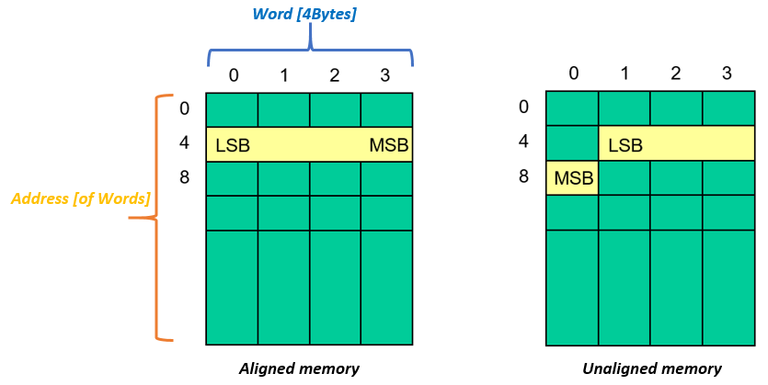**Note:** the memory access with ***VHDL_DUT_before*** design in ModelSim works well (simulation case behaves that each address value associated with a Word).

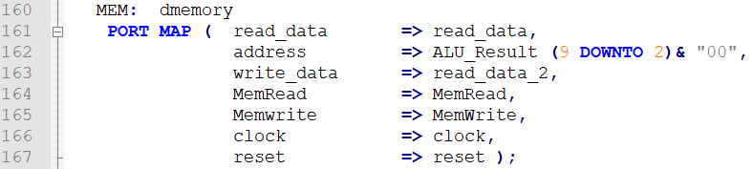

*See* ***DMEMORY.vhd***

*In* ***VHDL_DUT_after***



*See* ***IFETCH.vhd***

*In* ***VHDL_DUT_after***

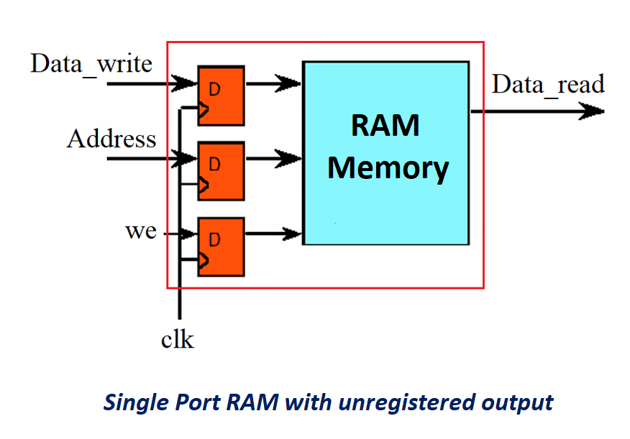***The given I-Chace (ROM type) and D-Chace (RAM type) memories are 4kB wide each:***

